## TEST RESULTS:

Testing the automation process:

### Task1:

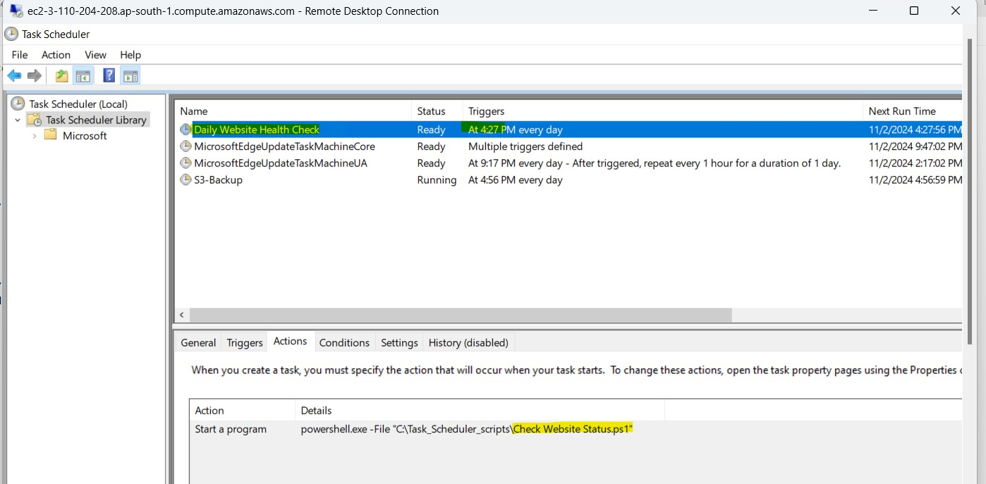

This hits the website daily which is hosted on IIS and generate logs:

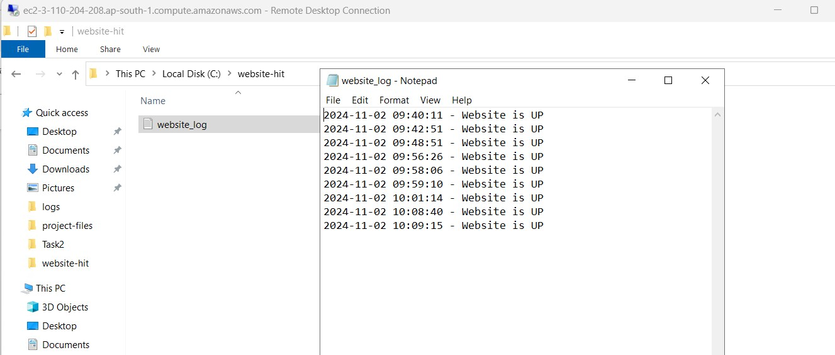

Log file Task 1:

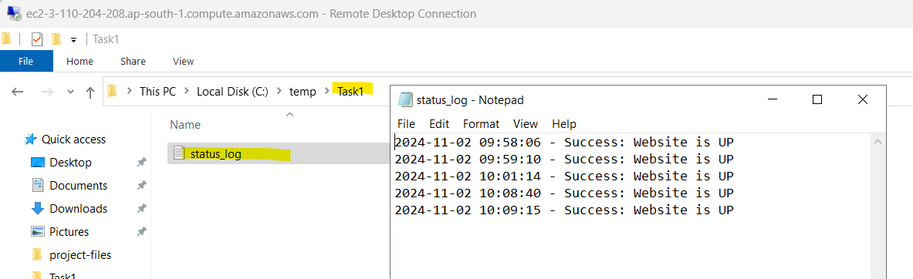

### Task2:

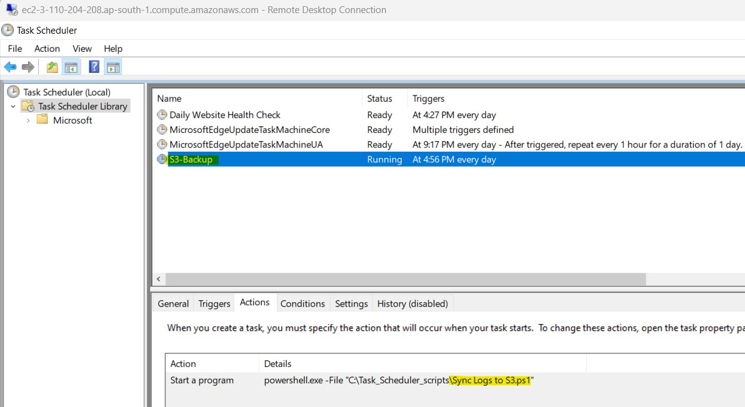

Whatever the logs generated, this will sync to S3 bucket.

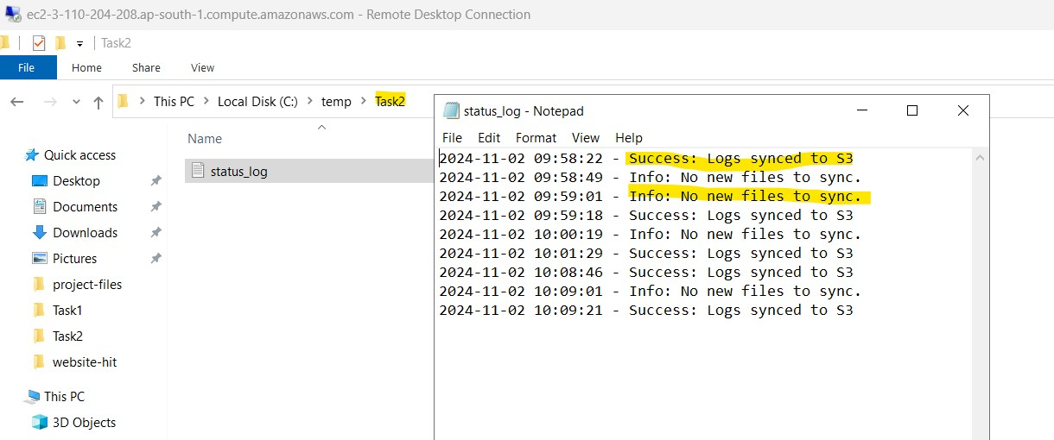

If there are any new files got generated/any modification, then it get synced to s3 bucket named **mtechproj**

### Files copied to S3:

**S3 backup to AWS backup vault (Mumbai):**

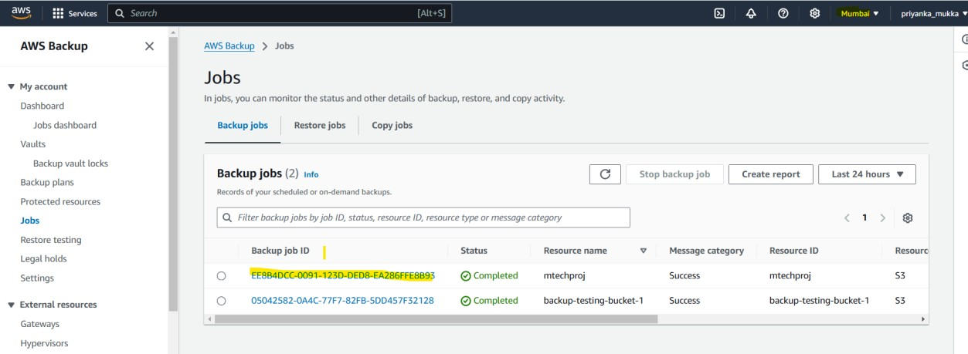

### SNS notification for start and complete Backup Job:

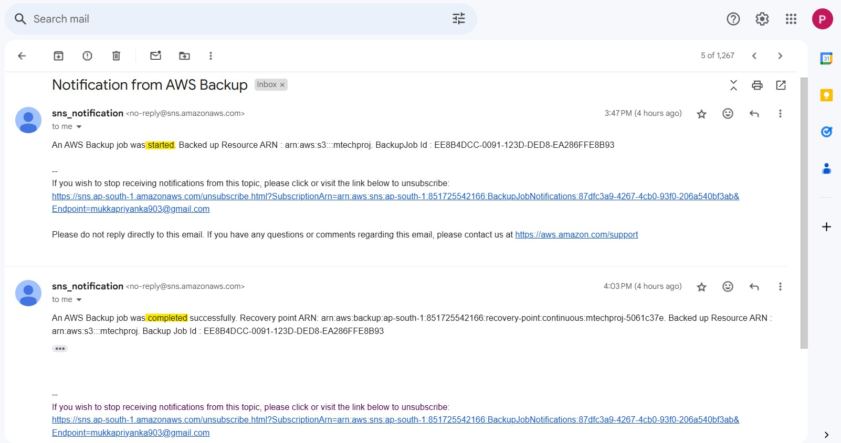

**Copy Job in Mumbai region:**

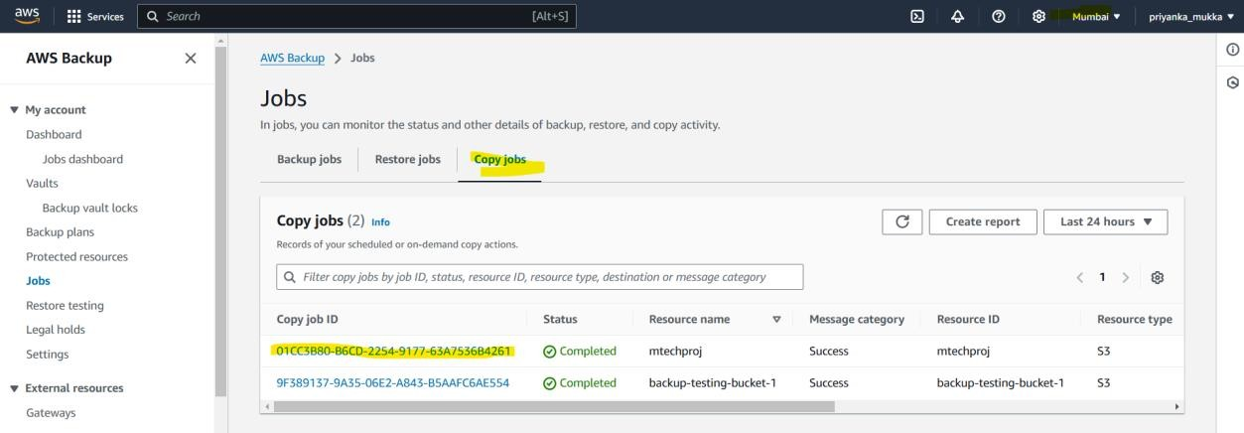

### Copy from AWS Backup Vault (Mumbai) to (Virginia)

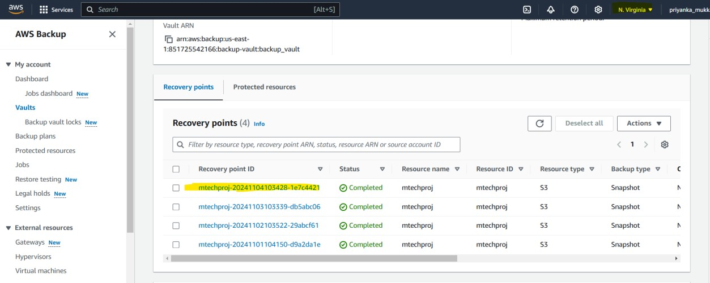

**Simple website hosted on IIS:**

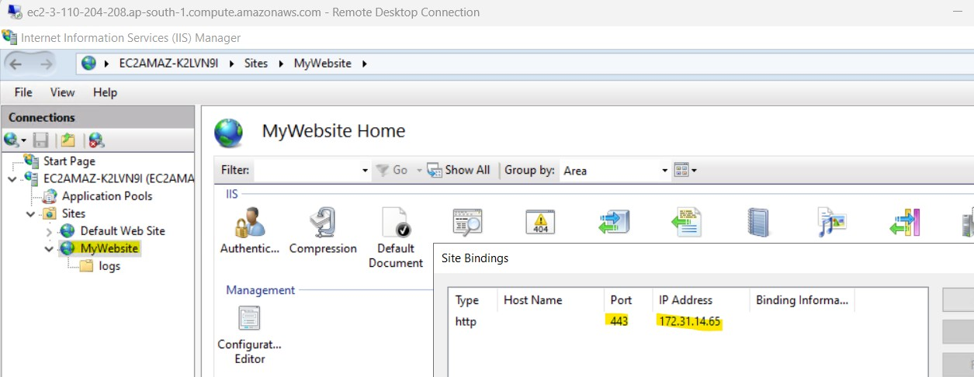

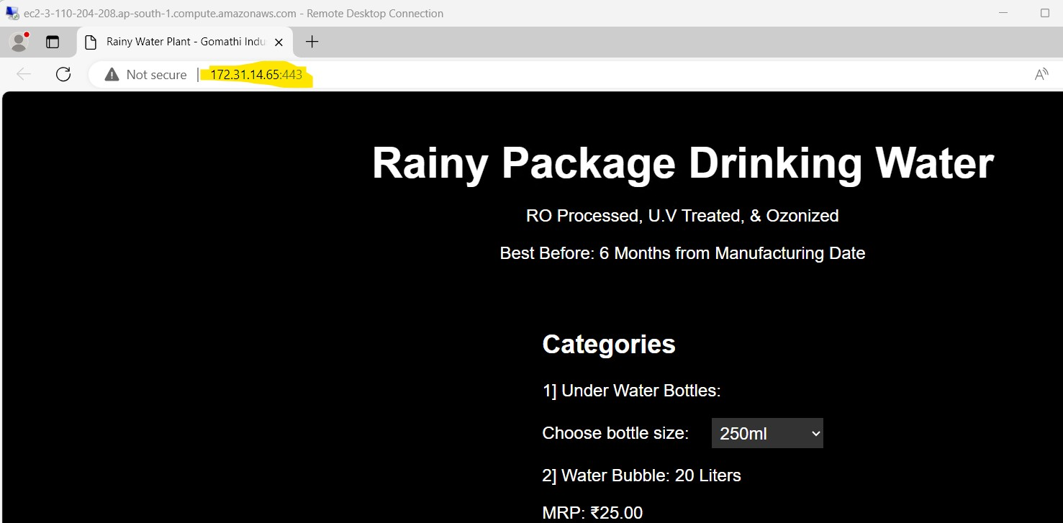

If any Disaster happen, how to restore the data:

Testing the Restore of files, in case of Disaster to recover files.

Steps: Using backup-testing-bucket-1 for testing. Deleting website_log.txt from bucket.

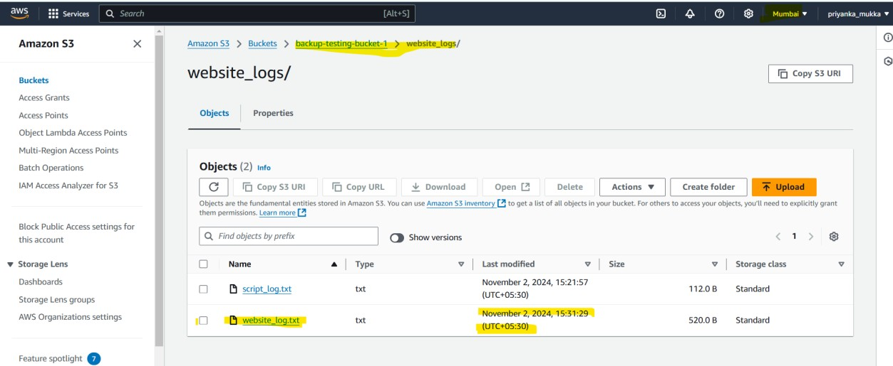

As we are having backups daily we have multiple versions of the file

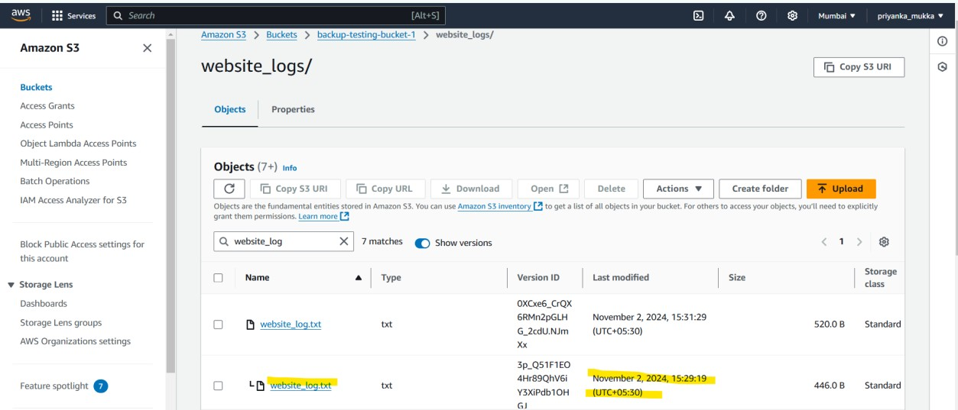

Resource[backup-testing-bucket-1] S3 bucket is assigned to backup-testing-plan under backup-testing-vault

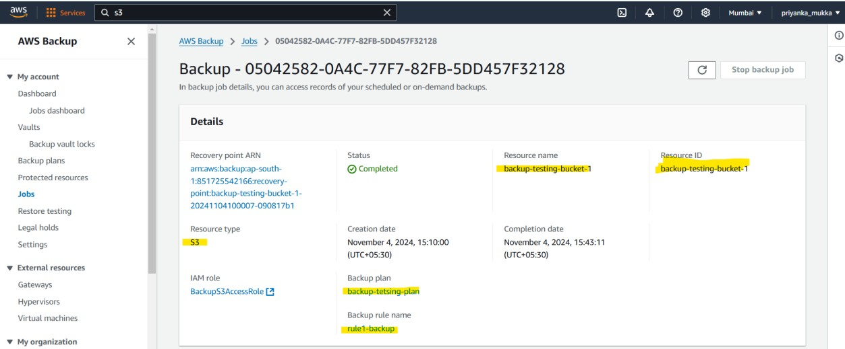

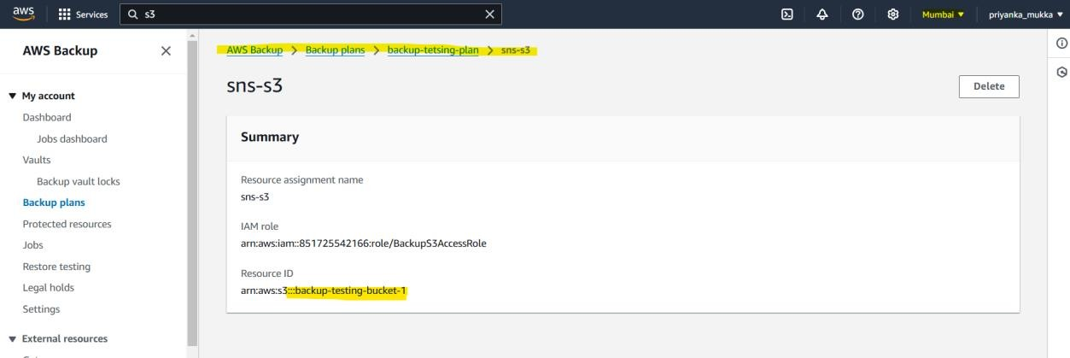

Deleted the website_log.txt from backup-testing-bucket-1 bucket

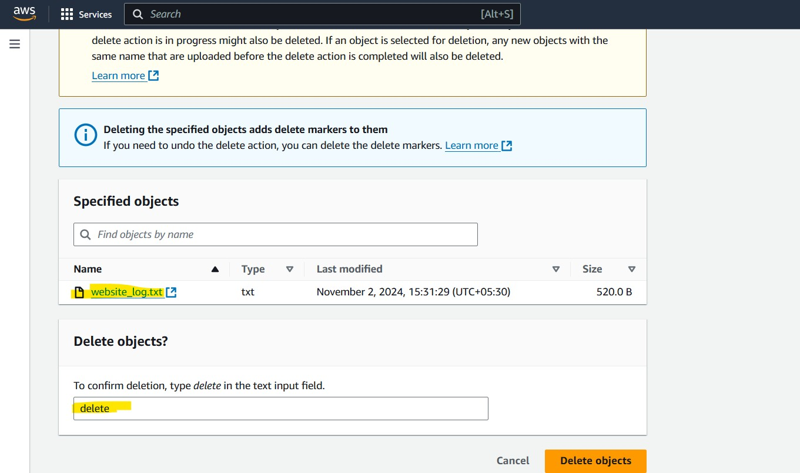

Deleted from bucket: No website_logs.txt is present in bucket

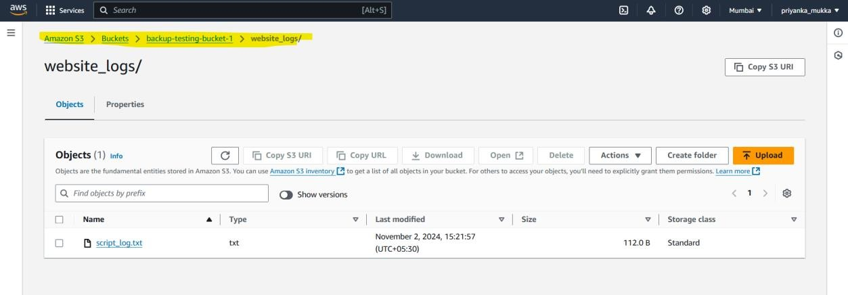

Let’s now restore the object in bucket

As per recovery point, could see last backup was taken on 4th Nov at 15:10

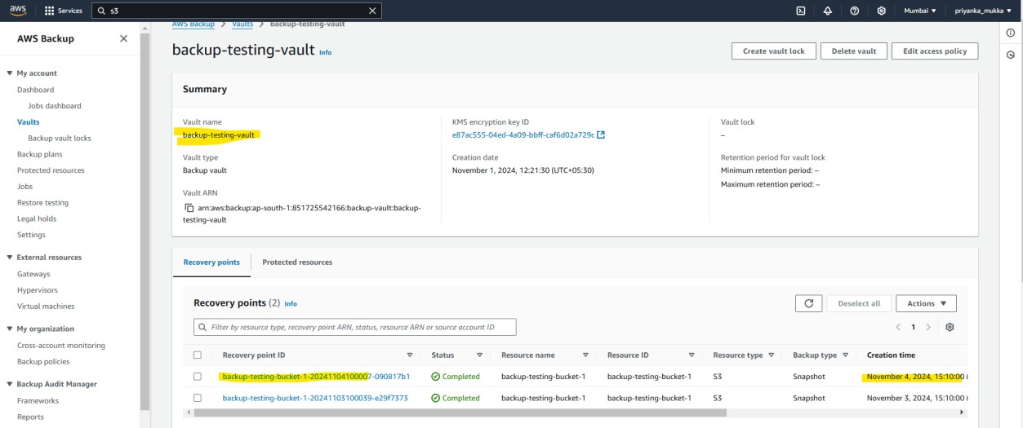

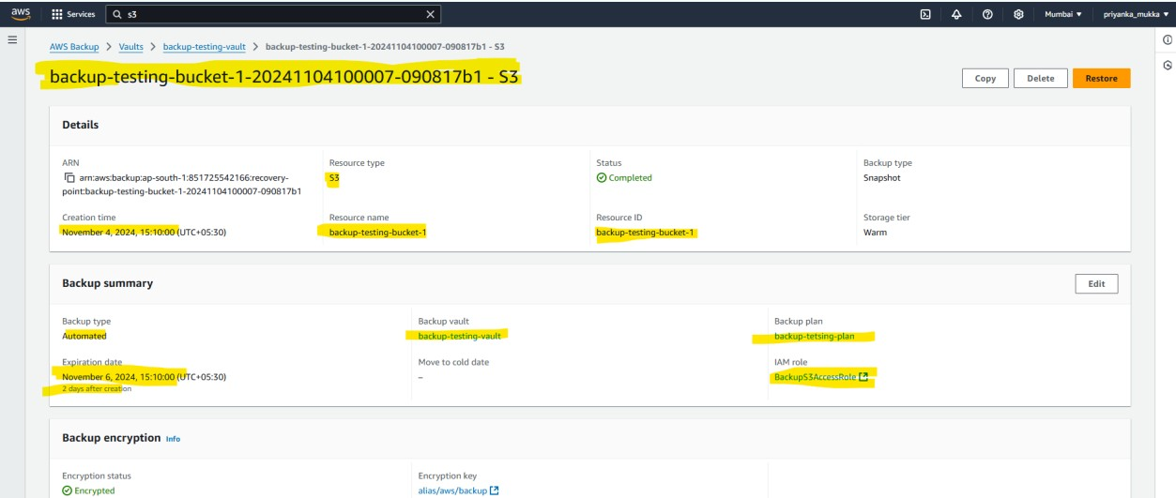

On top right-hand side, you can click on restore button on top left corner to restore data Let do this demo,

Soon you click on retore you can see few options.

You can restore entire bucket if it got deleted or you can restore particular file from bucket. Where to store the restored data. (in source bucket or any other bucket)

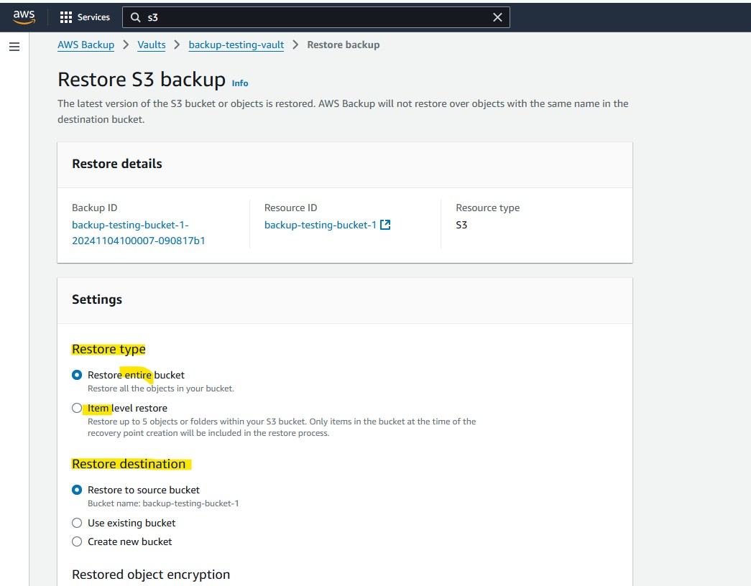

For now lets restore only one file which got deleted. (As it cost)

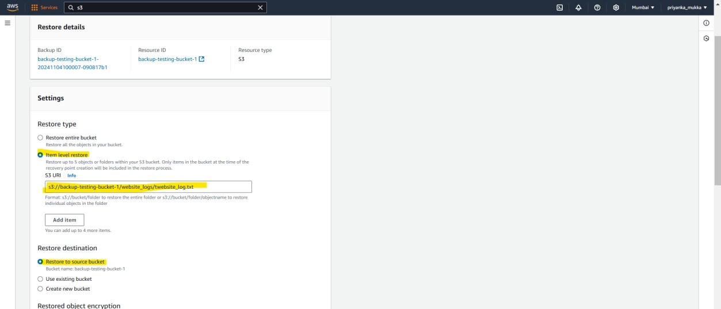

Provide ARN of s3 bucket or s3 object ARN to restore particular object. Choose IAM role which has permissions to do restore

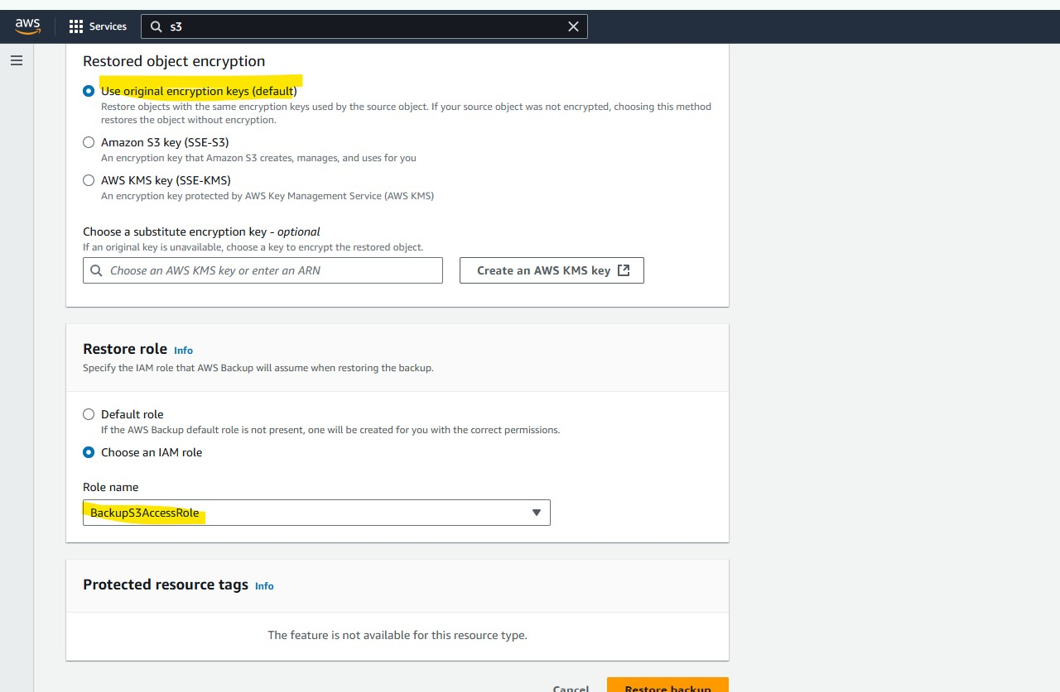

Click on Restore backup Restore is in progress

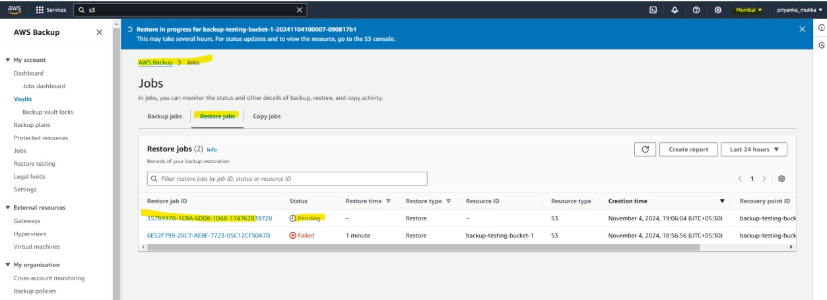

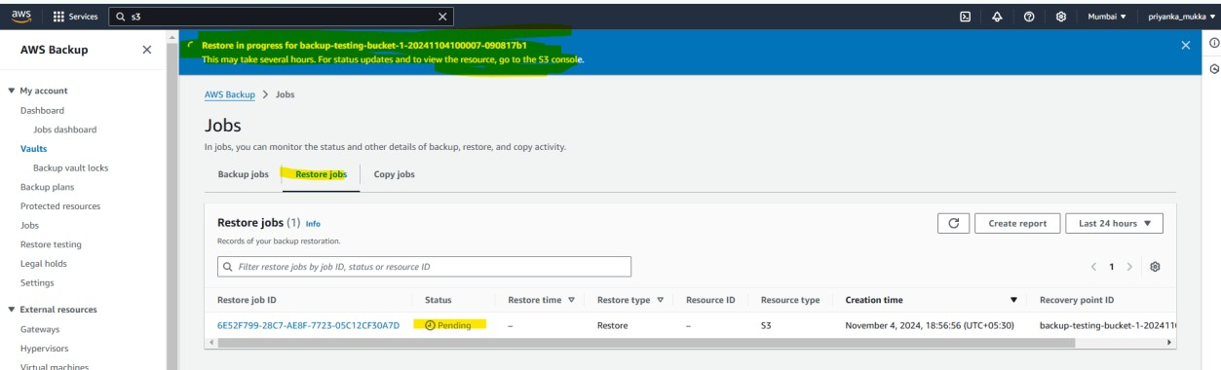

Just to show for now… no file is present in particular s3 bucket as restore is still pending

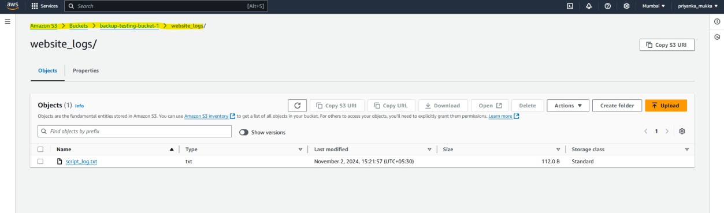

Let’s wait for the Restore Job Status to be completed:

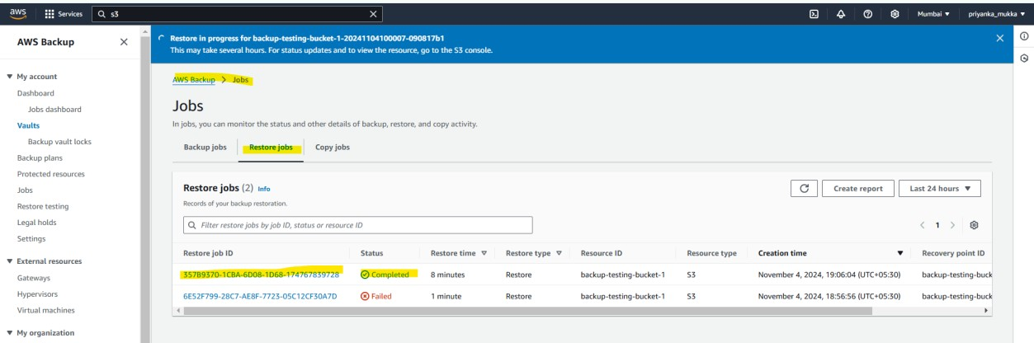

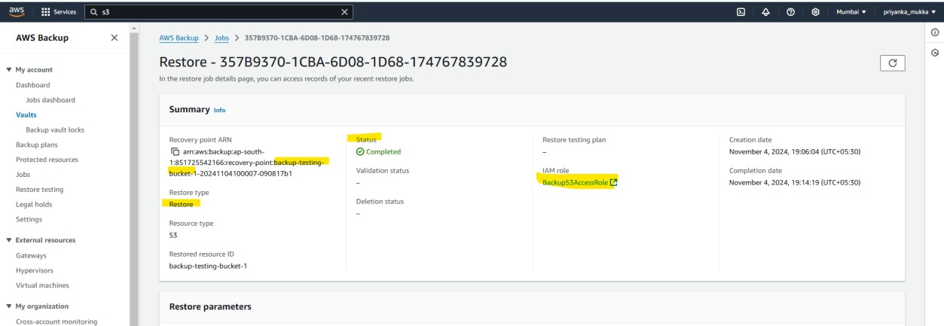

File restored in S3 bucket

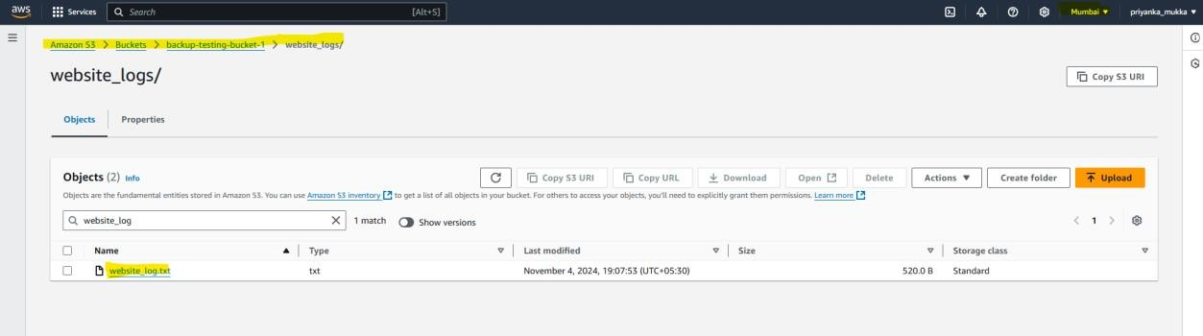

All versions of file are even backed up

